Ex4. Rat Race Royale

**Overview**

You and Aboud are playing a game called **Rat Race Royale**.

The rules of **Rat Race Royale** are simple. Just stand in a circle and… oh wait wrong game.

Initially, we start with the number **0**. The players take turns and at each turn the player can make the following move:

* If you have currently reached the number **i** then you can pick either **i+1 or i+k**

The first one to reach **x** wins! Assuming that both you and Aboud play **optimally**. If you start playing first, can you unravel the thrilling mystery of who shall emerge victorious in this exhilarating game?

**Requirements**

Implement the following function:

* bool **win**(int x, int k)  
  This function receives the values of **x** and **k** and returns **1** if you can win and **0** otherwise.

**Note.** Your solution must be implemented using dynamic programming. Both a top-down and a bottom-up solution are accepted.

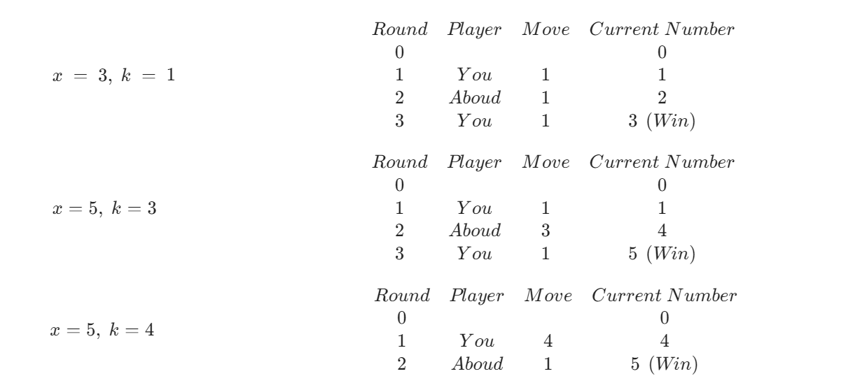**Hints**

This assignment is on dynamic programming which means we'll divide each problem into smaller sub-problems. But there's a slight twist in this problem. Instead of solving a typical optimization problem such as the one you've been solving in class by finding say the minimum or maximum of the sub-problems, instead our sub-problems are going to tell us whether this is a **winning state** or a **losing state.**